

Fisher College Falcons
2025-26 Women’s Basketball Roster

# Student-Athlete (10) Yr. Pos. Ht. Hometown Previous School
1 Kenuelys Velazquez Fr. G 5-2 Bayamon, Puerto Rico Elite Academy
2 Doha Marbouh Fr. G 5-4 Revere, Mass. Pioneer Charter
3 Anne Zamy Fr. G 5-4 Norwood, Mass. Norwood High
5 Christelle Jean Jr. G 5-2 Hampstead, N.Y. Massapequa High
6 Isabelle Jean Jr. G 5-2 Hampstead, N.Y. Massapequa High
10 Nada Boumkouk Jr. G 5-3 Agadir, Morocco Bunker Hill C.C. (MA)
11 Tyler Wilkerson Jr. G 5-1 Boston, Mass. Edward Kennedy Academy
12 Aliyah Shade Sr. F 5-8 Richland, Pa. Lackawanna College (Pa.)
13 Xhemile Avdyli Fr. F 5-5 Lynn, Mass. Lynn Classical High
23 Angelica Mejia Marinez Fr. F 5-8 East Boston, Mass. East Boston High

Head Coach: Vivian Lara (Fisher College ’20), 2nd Season
Assistant Coach: Mackie Chandler (Embry-Riddle ‘19), 1st Season


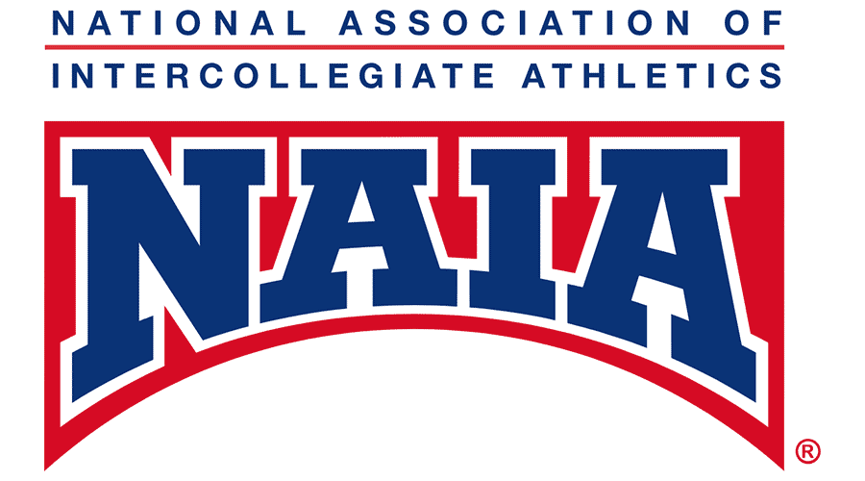

Pronunciation Guide

1 KEN-you-LEES Velazquez
2 DOH-ah MAR-bow
3 Anne ZAH-me
5 CHRIS-tell Jean
10 NAH-da BOOM-cook
13 Emily AV-dill-EE

