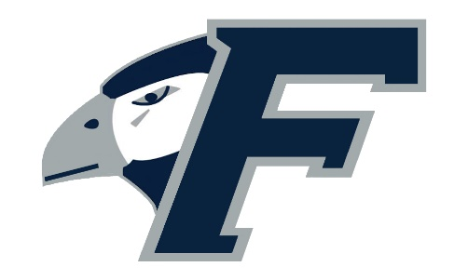

Fisher College Falcons
2025 Women’s Soccer Roster

# Student-Athlete (18) Yr. Pos. Ht. Hometown Previous School
1 Mariana Hernandez Cintron Jr. GK 5-4 Frisco, Texas Ottawa University (Ariz.)
3 Doha Marbouh Fr. F 5-4 Revere, Mass. Pioneer Charter
4 Gabriela Canaan Fr. B 5-4 Santo Domingo, DR Secundaria Babeque
5 Ari Pina So. B 5-5 Revere, Mass. Revere
7 Anai Vazquez So. F 5-3 East Boston, Mass. East Boston
8 Emely Fernandez Fr. M 5-7 Santo Domingo, DR American School of DR
9 Lea Bjorkhagen Jr. F 5-6 Stockholm, Sweden Notre Dame College (Ohio)
10 Nada Boumkouk Jr. F 5-3 Agadir, Morocco Bunker Hill CC (Mass.)
13 Xhemile Avdyli Fr. M 5-5 Lynn, Mass. Lynn Classical
15 Jenna Lindstrom So. F 5-4 Whitman, Mass. Whitman-Hanson
16 Dylan Ramirez Jr. B 5-7 Peoria, Ariz. Yavapai College
17 Yuliia Sokolova So. M 6-0 Dmipro, Ukraine Bedes (England)
19 Alina Molina Lara Jr. M/GK 5-7 Lawrence, Mass. Lawrence
21 Aliyah Shade Sr. F 5-8 Richland, Pa. Lackawanna College (Pa.)
22 Kendora Harper Jr. B 5-1 Laconia, N.H. Laconia
23 Sasha Therrien Dominguez So. F 5-4 Hesperia, Calif. Oak Hills
24 Breanyce Flete Fr. B 5-3 Haverhill, Mass. Haverhill
25 Chiara Sforza Jr. B 5-5 Medford, Mass. Medford

Head Coach: John Del Valle (Massasoit C.C. ‘06), 5th Season
Associate Head Coach: Joey Esteves (UMass-Lowell ’09), 3rd Season
Assistant Coach: Kristen Abreu (Regis College ‘16), 5th Season
Assistant Coach: Dan Ford-Hunt (Middlesex C.C. ’03), 2nd Season


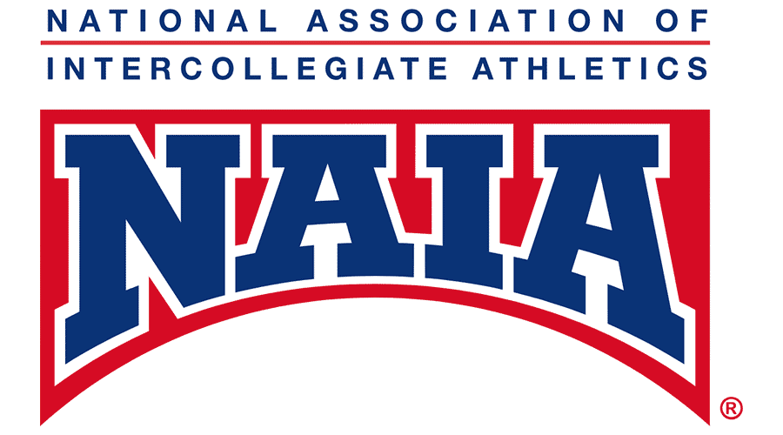

Pronunciation Guide:

3 Do-ha Mar-BOW
4 Gabriela CAH-non
9 Lea BEE-hork-HAG-en
10 Nada BOOM-cook
13 X-meal AHV-dee-LEE
17 You-lia Sock-o-low-vah
25 CHI-are-AH S-for-SAH

